**May 2016 HL P1**

**Section A**

1. Outline **one** problem of maintaining legacy systems. [2]

1. Outline the use of a failover system. [2]
2. Describe the function of the control unit (CU) in the central processing unit (CPU). [2]
3. Construct the truth table for the following expression.  
     
    A xor (B or C) [3]

1. In an 8-bit register, state the binary representation of the hexadecimal number 3B. [2]
2. The following list of numbers needs to be put into ascending order.

9, 11, 3, 4, 5, 7, 1, 2

State the list that would be obtained after **two** iterations of a bubble sort. [1]

1. Outline why a virtual machine is an example of abstraction that is particularly useful when

testing software on different platforms. [3]

1. Explain, in terms of resources, how Voice over IP provides a collaborative working environment

for a company with multiple locations nationwide. [3]

1. Explain **two** functions that an operating system needs to perform in relation to multitasking. [4]
2. Discuss **one** ethical consideration of using CCTV in a workplace. [3]

**Section B**

1. An examination office of a university must securely store students’ examination papers and

their grades. The office keeps the documentation of past students for two years. After two

years the office only stores the student grades. All documentation of current students is

frequently accessed for other operations and the volume of the data increases quickly.

To better support its operations, the office is creating a new system to provide this storage.

1. Identify **two** aspects of the data that need to be taken into account during the planning

of the new system. [2]

1. Describe how direct observations on the current system may provide information to

help propose a suitable new system. [3]

A prototype of the new system is created to present to the examination office.

1. Describe the purpose of this prototype. [3]

The examination office needs to upgrade the computing resources for their operations, and  
 this will require data migration.

1. Discuss **two** possible problems that may occur during data migration. [4]
2. Outline **one** economic aspect that the examination office needs to take into account to

support parallel running. [3]

1. A college has a high-speed network. The network is accessible to all students and staff

through their personal accounts.

The network may be accessed by using desktop computers available in the college. When

in the college, users can also use personal laptops to connect wirelessly or dock with an

Ethernet cable. When not in the college, users can connect via a virtual private network (VPN)

over the internet.

1. In the given context, distinguish between Ethernet and wireless in terms of **reliability**

of transmission. [4]

1. Describe **two** features of a VPN that make it secure. [4]
2. State one technology that is necessary for a VPN. [1]

The college is devising a policy for the use of its IT resources and services. They are  
 considering prohibiting the use of external services such as cloud storage and blogs.

1. In relation to the specific activities that may be carried out by students, discuss **two**

advantages and **two** disadvantages of the use of external services. [6]

1. A car park has two barriers. One barrier is at the entrance, where tickets are **issued**, and

one barrier is at the exit, where paid tickets are **checked** when cars leave. A display at the

entrance, showing the current availability of spaces in the car park, is updated as tickets are

**issued** and **checked**.

The actions of issuing, paying and checking a ticket operate on the collection of objects,

TICKETS, that is organized as a linked list. Each object holds the following information:

Nr: ticket number (a progressive unique identifier)

Date: date of issue

Arrival: time of issue (in 24-hour format)

PaidOn: date of payment

PaidAt: time of payment (in 24-hour format).

1. Describe how a linked list is a suitable data structure for the given scenario. [2]

When a car arrives and the car park is not full, a ticket is issued, the entrance barrier is  
 raised and the display is updated.

Payment of a ticket at a machine updates both the ticket and its object representation held in  
 the linked list. The car must exit the car park within 10 minutes.

At the exit barrier the ticket is checked, and this makes the barrier rise and updates the display.

1. For the given scenario, identify:
2. **one** example of two processes that could occur concurrently [1]
3. **one** example of two processes that could not occur concurrently. [1]

1. State the condition that needs to be checked on the ticket when a car leaves the car park. [1]

A car arrives at the entrance barrier while another car is at the exit barrier.

1. Explain the order in which the operations for raising the barriers and updating the

display should be performed, to ensure a correct and efficient management of the

car park. [3]

Upon payment, the PaidOn and PaidAt fields are populated in the corresponding object,  
 without removing it from the linked list.

1. Outline **one** implication of this choice of design in terms of efficiency. [2]

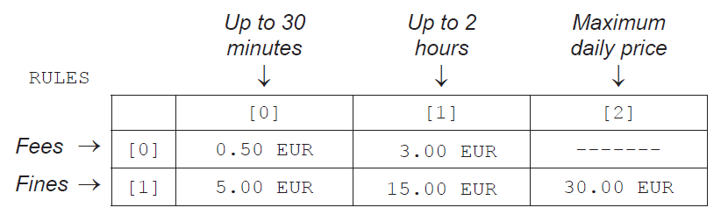 The car park rules enforce a short-stay policy. Staying in the car park for up to 2 hours is  
 allowed, and is subject to two possible **fees**. Staying in the car park for durations longer than  
 two hours is subject to three possible **fines**, in addition to the original fee, up to a maximum  
 price for each day. Tickets are paid in Euros (EUR).  
  
 The possible fees and fines are stored in a two-dimensional (2D) array, RULES.

For example:

* staying in the car park for 40 minutes costs 3.00 EUR
* staying in the car park for 3 hours costs 3.00 + 15.00 = 18.00 EUR
* any stay in the car park that exceeds 4 hours costs 30.00 EUR
* a stay that spans two consecutive days, regardless of duration, costs 60.00 EUR.

1. Construct the steps of an algorithm that calculates the amount that a ticket is to be

charged. [5]

1. LookUpLunch is an app for a Smartphone that can be used to search for restaurants located

in zones of increasing distance from the user’s current position. The diagram shows the user

and zones as they would appear on a map of the area.

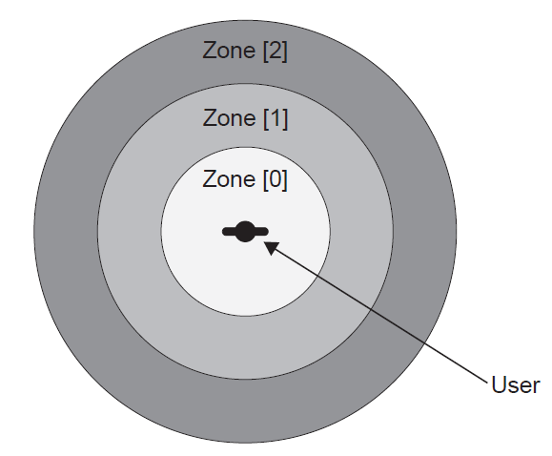

A search in Norway produced the following table, RESULTS, which shows the number of  
 restaurants in each zone. RESULTS also displays the average price for a meal, expressed in  
 the local currency (Norwegian Krone, NOK).

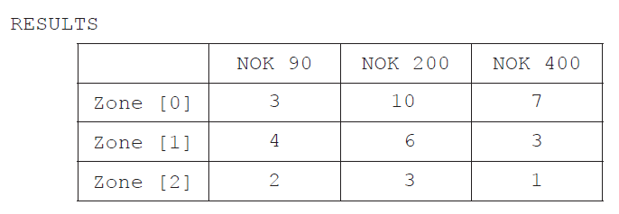

1. Using the table, state the total number of restaurants in the zone furthest from the user. [1]
2. Suggest how the zones are calculated and displayed on the map using GPS based

technology. [4]

**Another** Smartphone app that is linked to LookUpLunch collects customers’ reviews for

restaurants.

A review consists of whether a customer likes the restaurant, and a rating of cheap (C),

medium (M) or expensive (E). The app combines all of the reviews to produce a single letter

rating (C, M or E) and a total number of likes for the restaurant.

As part of the internal representation of the app, the collection LIKES is used. Some of the

data items contained in LIKES are shown below. Each individual data item is separated by

a comma.

0,26,TomHus,M,1,14,GladLaks,E,2,1,MerPoteter,C,1,15,Linie,E,0,2,Mezze,M…

The restaurant GladLaks, underlined as an example, is located within zone [1]. Based on the

reviews, this restaurant has 14 likes and is expensive.

1. Construct an algorithm that outputs the name of the restaurant with the most likes in

zone [1]. [5]

1. By making use of binary trees and the collection LIKES, explain how a list could be

produced that shows the restaurants in order of zone and then, within each zone, in

order of popularity. [3]

Individual restaurants are able to use this app to see reviews from their customers.

1. Describe one disadvantage of the use of feedback from social networking in relation to

business. [2]

1. The letters F0, F1, F2, …, FN , …, where N ≥ 0, are used to identify the N th term of the

sequence of Fibonacci numbers that starts as follows.

0 , 1 , 1 , 2 , 3 , 5 , 8 , 13 , …

With the exception of the leading 0 and 1 (the zeroth term and 1st term), the terms in

the sequence are the sum of the two preceding terms. For example, F5 is the 5th term

of the sequence, which is 5, and is the sum of the 3rd and 4th terms, which are 2 and 3

respectively.

1. State the value of the 8th term in the sequence. [1]

The following method, fibo(N), generates the N th term in the sequence. The return  
 statement returns the value that the method generates.

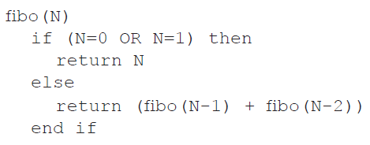

1. Trace fibo(4), showing the different levels of recursion. [3]
2. Construct a non-recursive algorithm to generate Fibonacci numbers. [6]
3. Construct an algorithm that will **output** the first N terms of the sequence. You should

use fibo(), the method defined above. [3]

Recursive programs written in high level languages require the use of particular structures to  
 support their execution.

1. Describe how a stack is usually employed in the running of a recursive algorithm. [2]